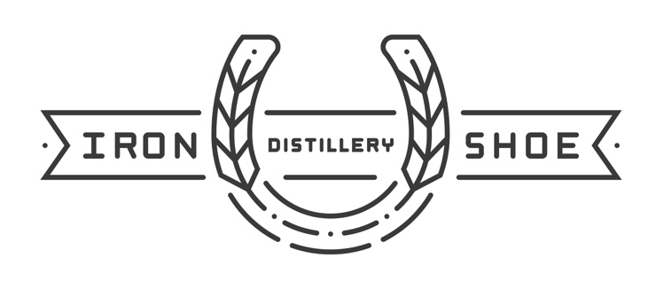

THE TWO HORSE SALOON
One rad beverage wagon.
EVENT RENTAL REQUEST FORM

NAME:

PHONE:
EMAIL:

EVENT DATE:

EVENT START & END TIME:

TYPE OF EVENT:

EVENT VENUE/LOCATION (INCLUDING ADDRESS):

NUMBER OF GUESTS:

OTHER IMPORTANT DETAILS:

SPECIAL REQUESTS:

IRON SHOE DISTILLERY
3 NORTH 3RD STREET | NILES, MICHIGAN | 49120

Please return complete form to Laura Tuthill at ltuthill@ironshoedistilling.com

